Solution

Lookup Information with Duplicate Values
- Open the exercise file, ‘Exercise Solution - Lookup Information with Duplicate Values.xlsx’.

Create a Unique Lookup Value
We need to create a unique lookup value by combining the text in column C with the text in column D. We can do this using a ‘Helper’ column.
- In column B, add the heading ‘Helper’.
- Join together the text in column B with the text in column C.
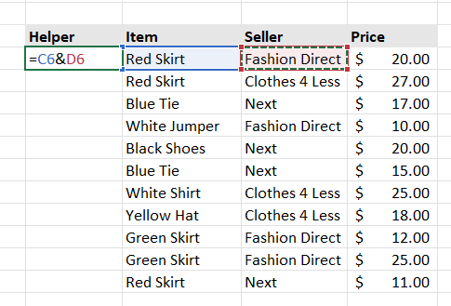
- Copy the formula down.
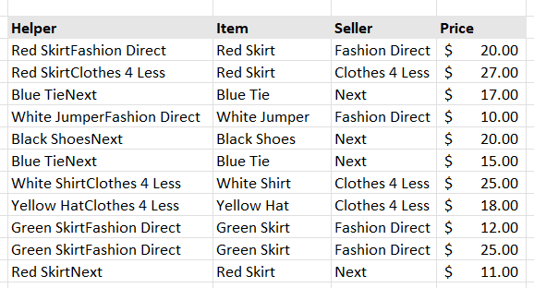

Create the VLOOKUP Formula
- Click in cell I6.
- Type the following formula.
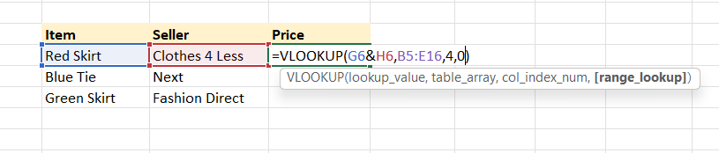
- Copy the formula down.
- Select the ‘Helper’ column.
- Right-click and choose Hide.

