Solution

Pareto Principle
If constructing the chart in Excel, use the Combo Plot, Clustered Column - Line.
The process with the most errors is the Order Entry process followed by the Order Shipping process and Order Consolidation process. These three contribute nearly 80% of the errors. Lean Six Sigma projects should be started on all three, with priority given to the Order Entry process.
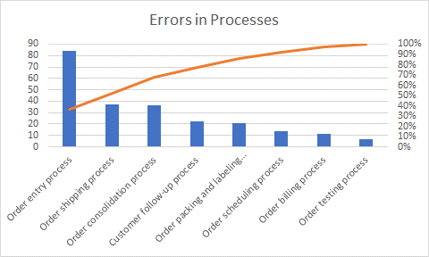
The most frequent cause of defects was transporting the product to/from the stockroom. Assembly damage and improper training were the next two. The analysis should investigate each of these in more detail to determine the root causes of these problems.
