Solution

Create a Survey

​Forms vs Survey vs Quiz

A Form
A form is something that people fill out where they provide personal details and information, like on an application form.
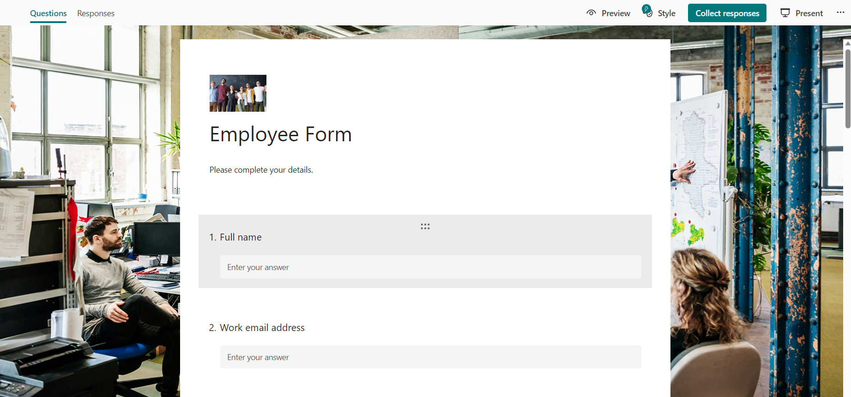

A Survey
A survey is also a form, but it is used to gather feedback and opinions from others via a series of questions.
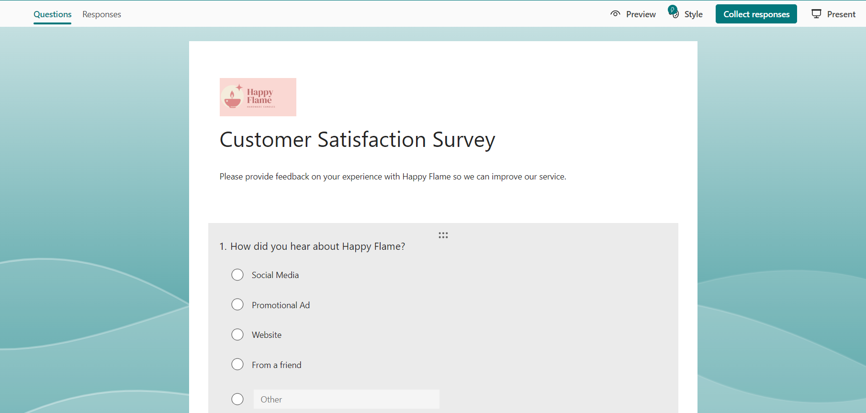

A Quiz
A quiz is a form but the aim is to test people's knowledge on a subject and award points.
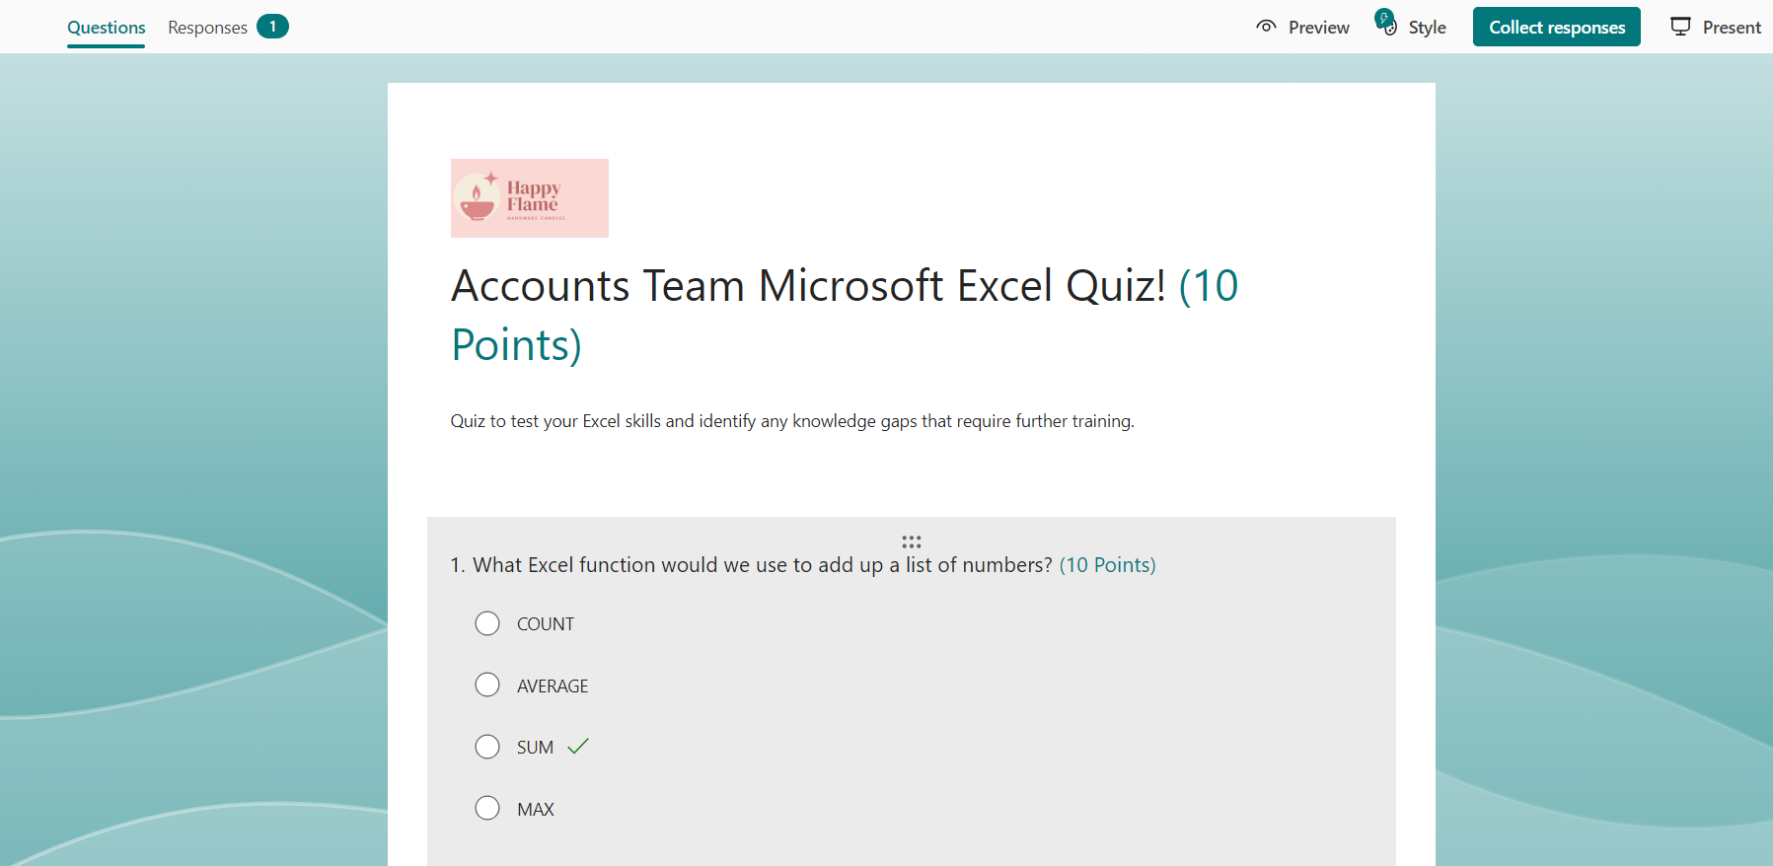​

Create a Survey
- Click New Form.
- In the 'Untitled form' field, type ‘Apex Gym Member Survey’.
- In the form description field type, ‘Survey to capture valuable feedback from our loyal members’.
- Click the image icon next to the survey name.
- Click Upload.
- Navigate to the folder where you have saved the photo ‘gym1.jpg’.
- Click Open to upload.
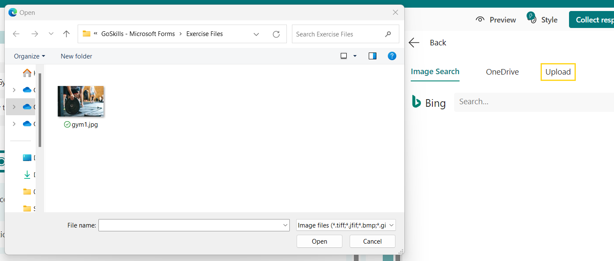
- Click the alternative text icon that is displayed over the image.
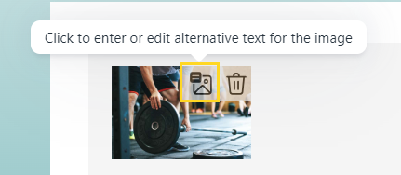
- Type a sentence that describes the image in detail.
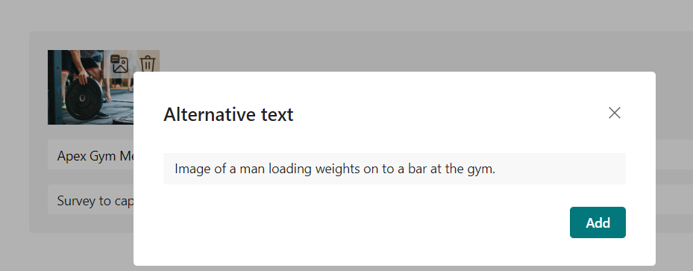

Preview the Form
- Click the Preview button.
- Click on Computer and then on Mobile.



