Solution

Email Signatures

Instructions:
Open a new email message window.
- On the ‘Message’ ribbon, click the Signature button, 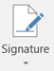 then click the 2nd Signature button
- Click ​
- Type a Name for your signature file: 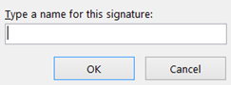​
- Begin to edit your signature making good use of the formatting tools available, and add your photo or company logo / web links:
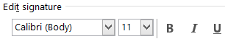​​
- The last step is to make sure you designate which signature to use for New messages and Replies/forward messages:
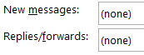​
After creating at least two personal signatures, practice selecting them using the right-click in a brand new email.
To use when drafting a new email, and quickly switch the signature choice, simply Right-Click the automated signature and choose from the list that appears on the message screen. (Must have at least 2 signatures set up for this to work.)
