Exercise

Follow Up Flags and Categories
Follow along with the video and the reference guide and practice using Follow Up flags and Categories. Spend time in your Category Colors and name and color your list. Note: This list will be the same in your Calendar and Contacts.

- FLAGS: Along the right side of the Inbox is a set of grey flags. Click a flag to turn it Red:

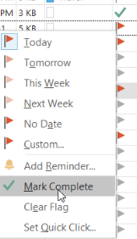
- When finished with the item, click the FLAG again to place a check mark “finished” icon, or Right click the flag and
select “Mark Complete”.
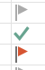

- Note: After 24 hours, a Flagged email will appear with red text in your inbox:
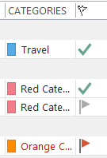
- CATEGORIES: Also along the right side of the Inbox, Categories apply a small dab of color to visually prioritize your similar topics:

- To rename or choose from the 25 available colors:
Note: This list will be the same in your Calendar and Contacts.

  - Right click a Category (or select the Categorize button on the HOME ribbon) and choose “All Categories”.
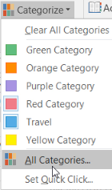

  - Choose a Category, click ‘Rename” and label it, then choose a new color:
