Solution

What is Microsoft Teams and When to Use It
- Do a Google search for “Microsoft Teams.” Find the main offering page for Teams from Microsoft. Review the offerings.
- Search for Microsoft Teams, then click on the top item.
- Select Plans and Pricing
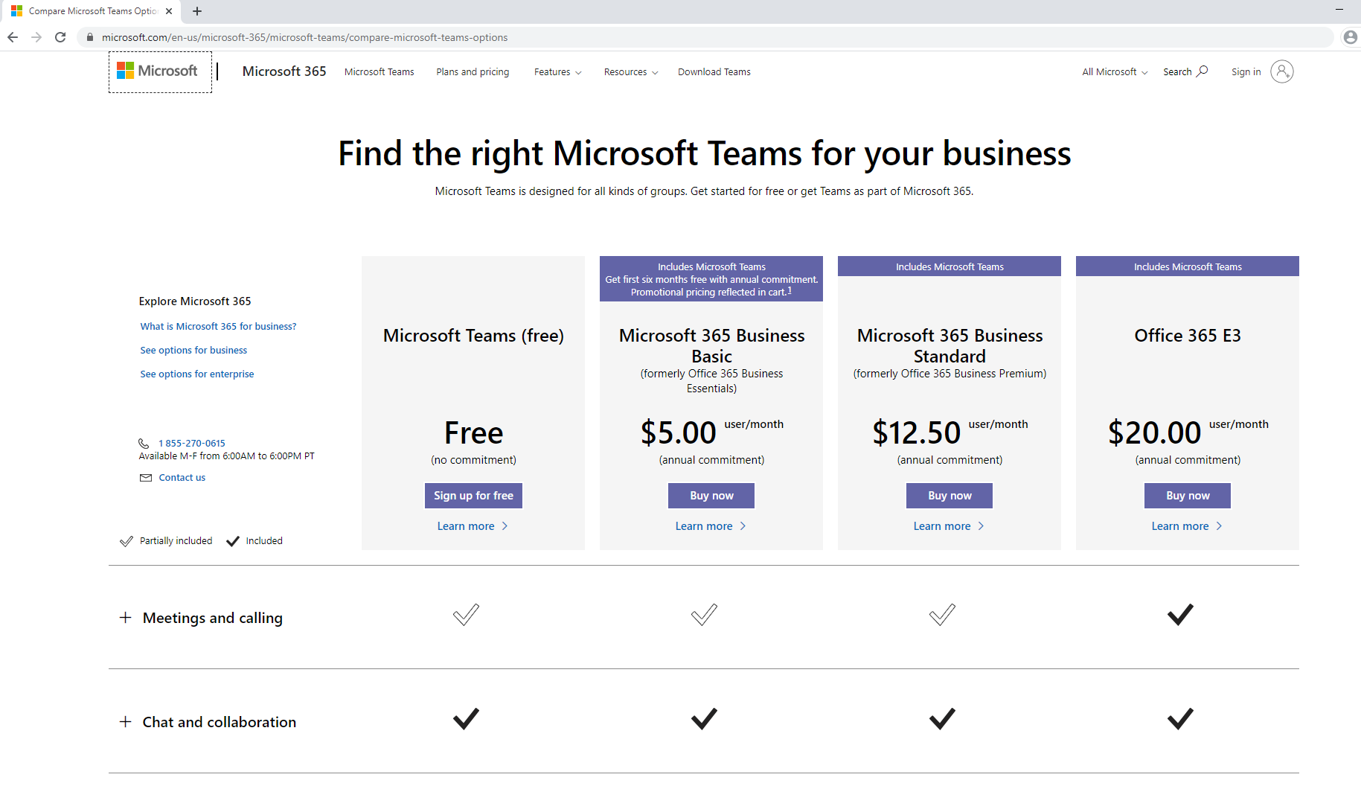

- Locate the Microsoft Teams blog and subscribe to notifications

- Search for Microsoft Teams blog
- Click on Microsoft Teams Blog – Microsoft Tech Community
(https://techcommunity.microsoft.com/t5/microsoft-teams-blog/bg-p/MicrosoftTeamsBlog)
- Click on Follow and login with a Microsoft account where you can receive notifications
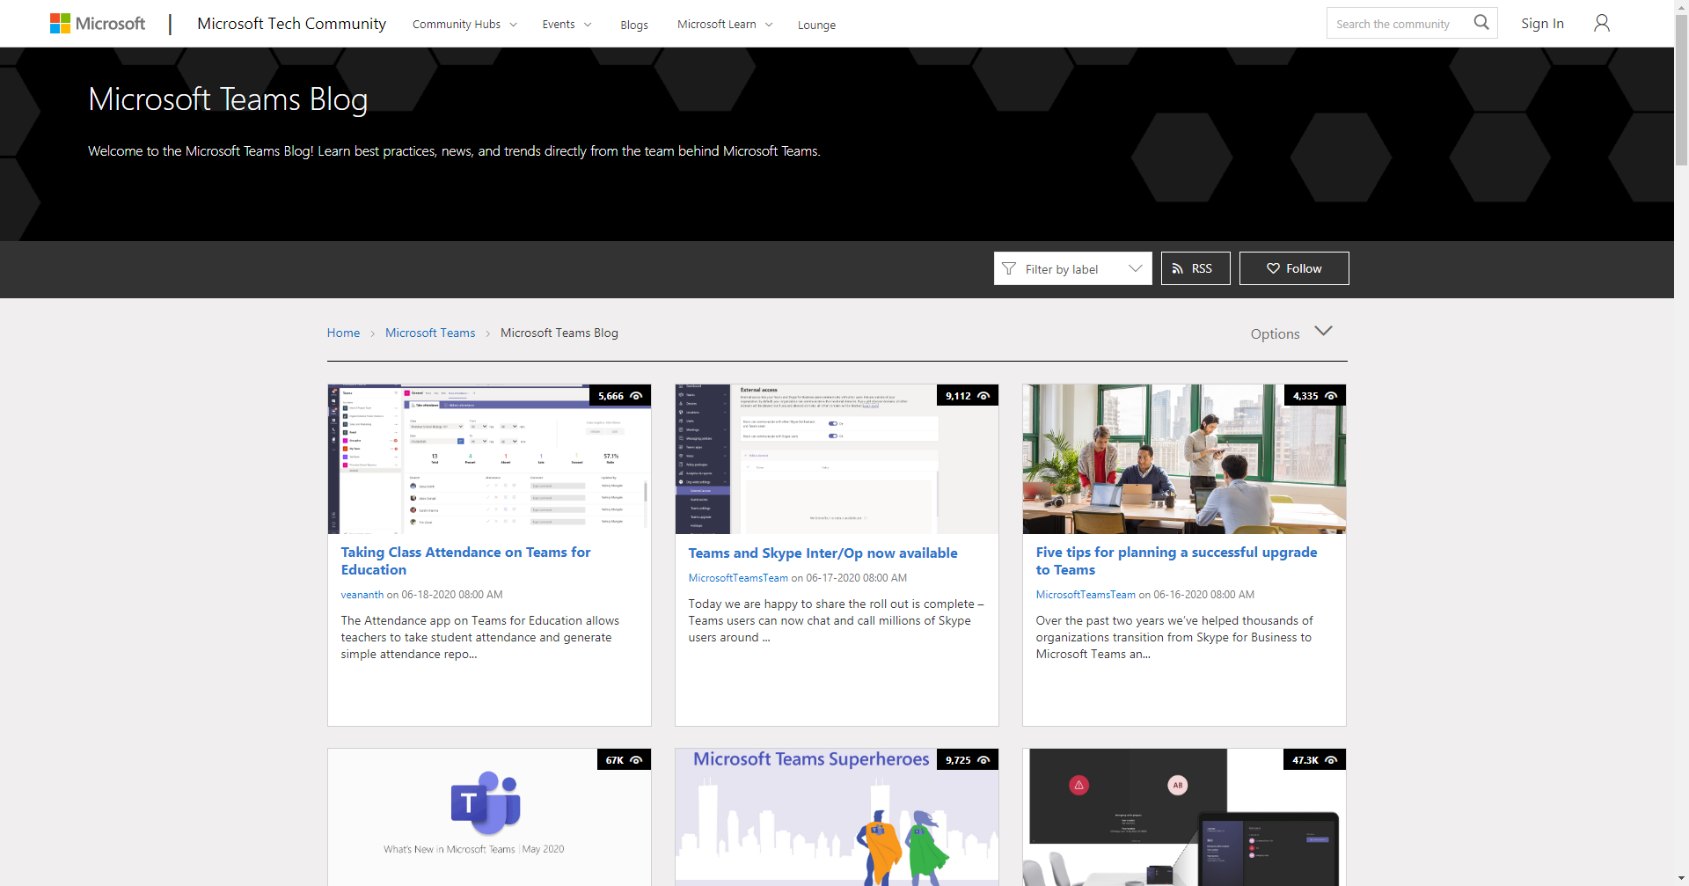

Exercise notes

