Solution

Posting and Sharing a Document in Teams
Posting a Document to Teams using Teams Chat
Shown below is the File->Save As menu which also includes a Download option.
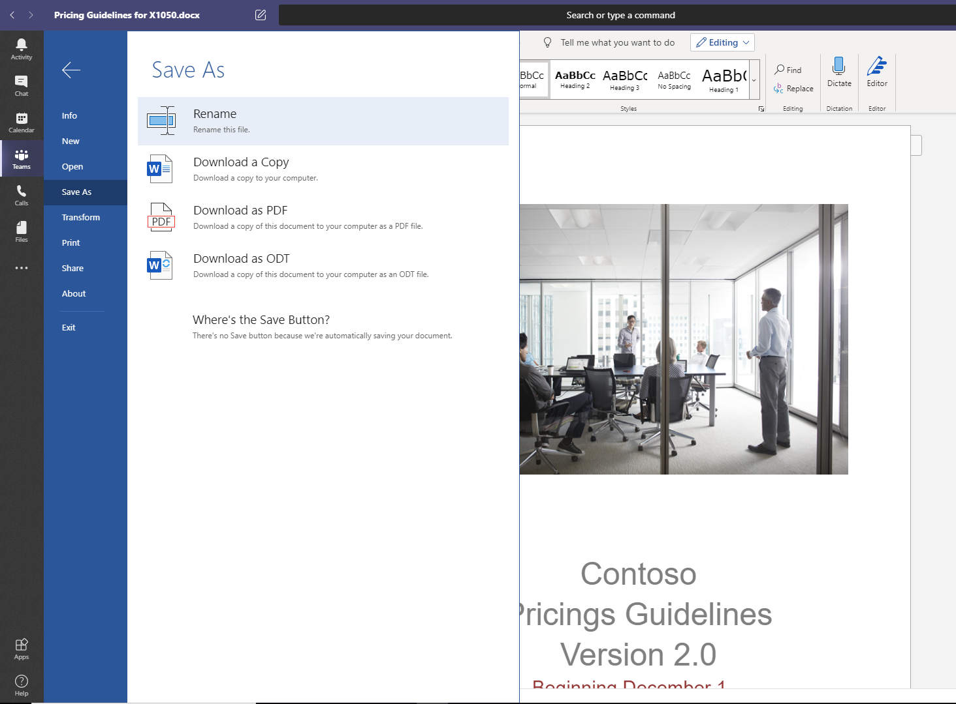
Click on the Files menu option on the left sidebar, and notice that your document is not only available in the channel feed, but can easily be located in the Files listing from the left sidebar.
Posting and Sharing Document to Teams using the Files Tab
To copy the URL for sharing, select the document in the list of files and then click on the ellipses (…). The menu below is shown which includes Copy Link.
