Solution

Joining and Participating in a Teams Meeting
Part 1: Setting up Side-by-Side users
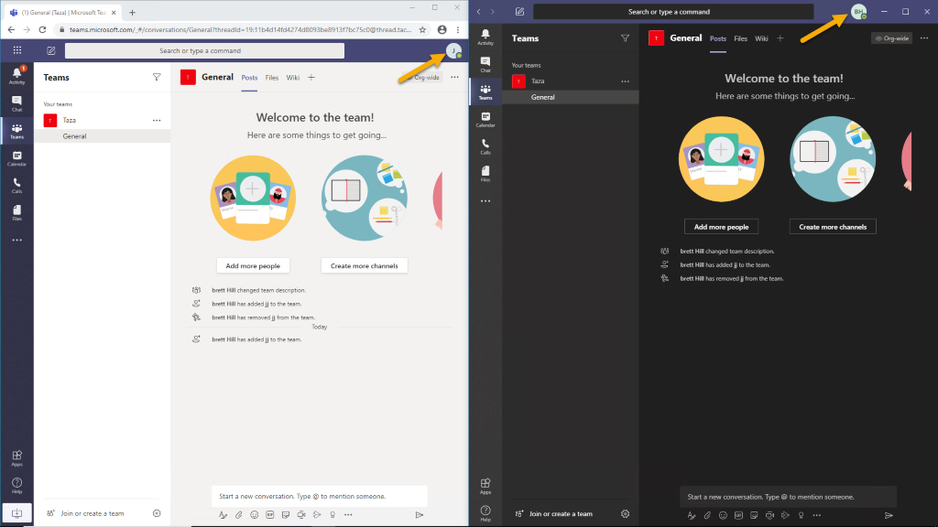

Part 2: Start and then join a meeting in the Teams desktop client
After clicking Join, when you click the ellipses and Device settings, you should see:
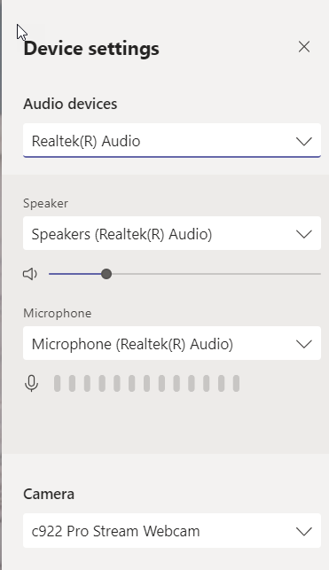

When you select Background settings, you should see:
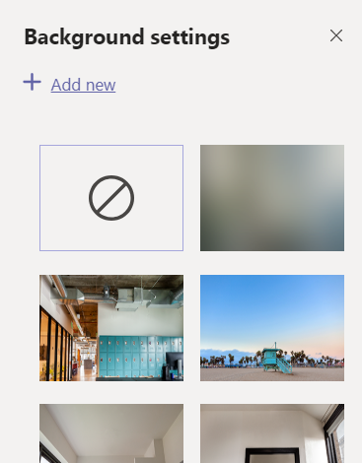

Part 3: Join a meeting with the Teams web client
For the web client, note that you cannot change the background.
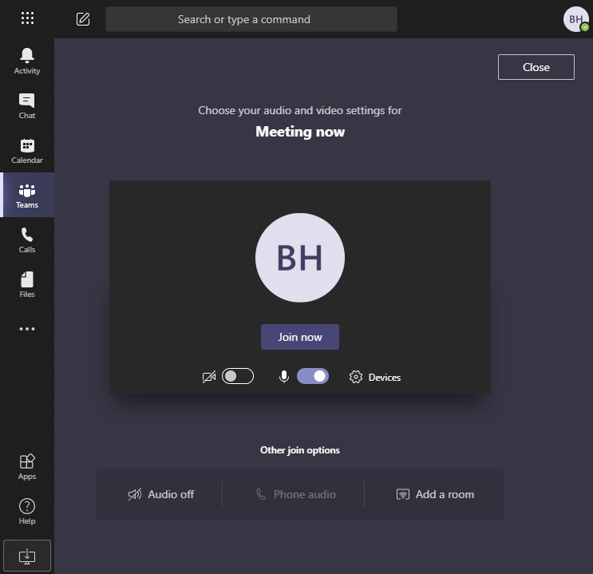

Part 4: Meeting chat
When you click on Show Conversation, you can format meeting chat text like you can in Teams chat.

Part 5: Private Chat during a meeting and working in Teams during a meeting
The screenshot below shows starting a chat by typing a message into a contact card.
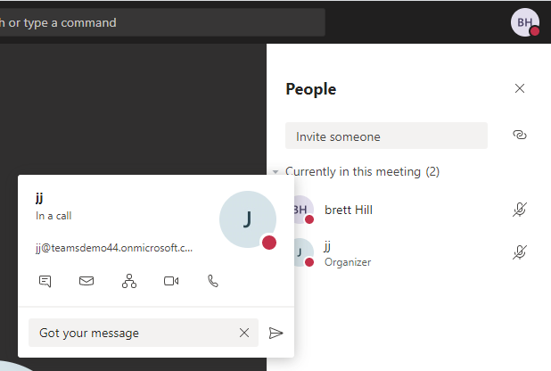

When in a meeting, you can still work in Teams without disrupting the meeting.
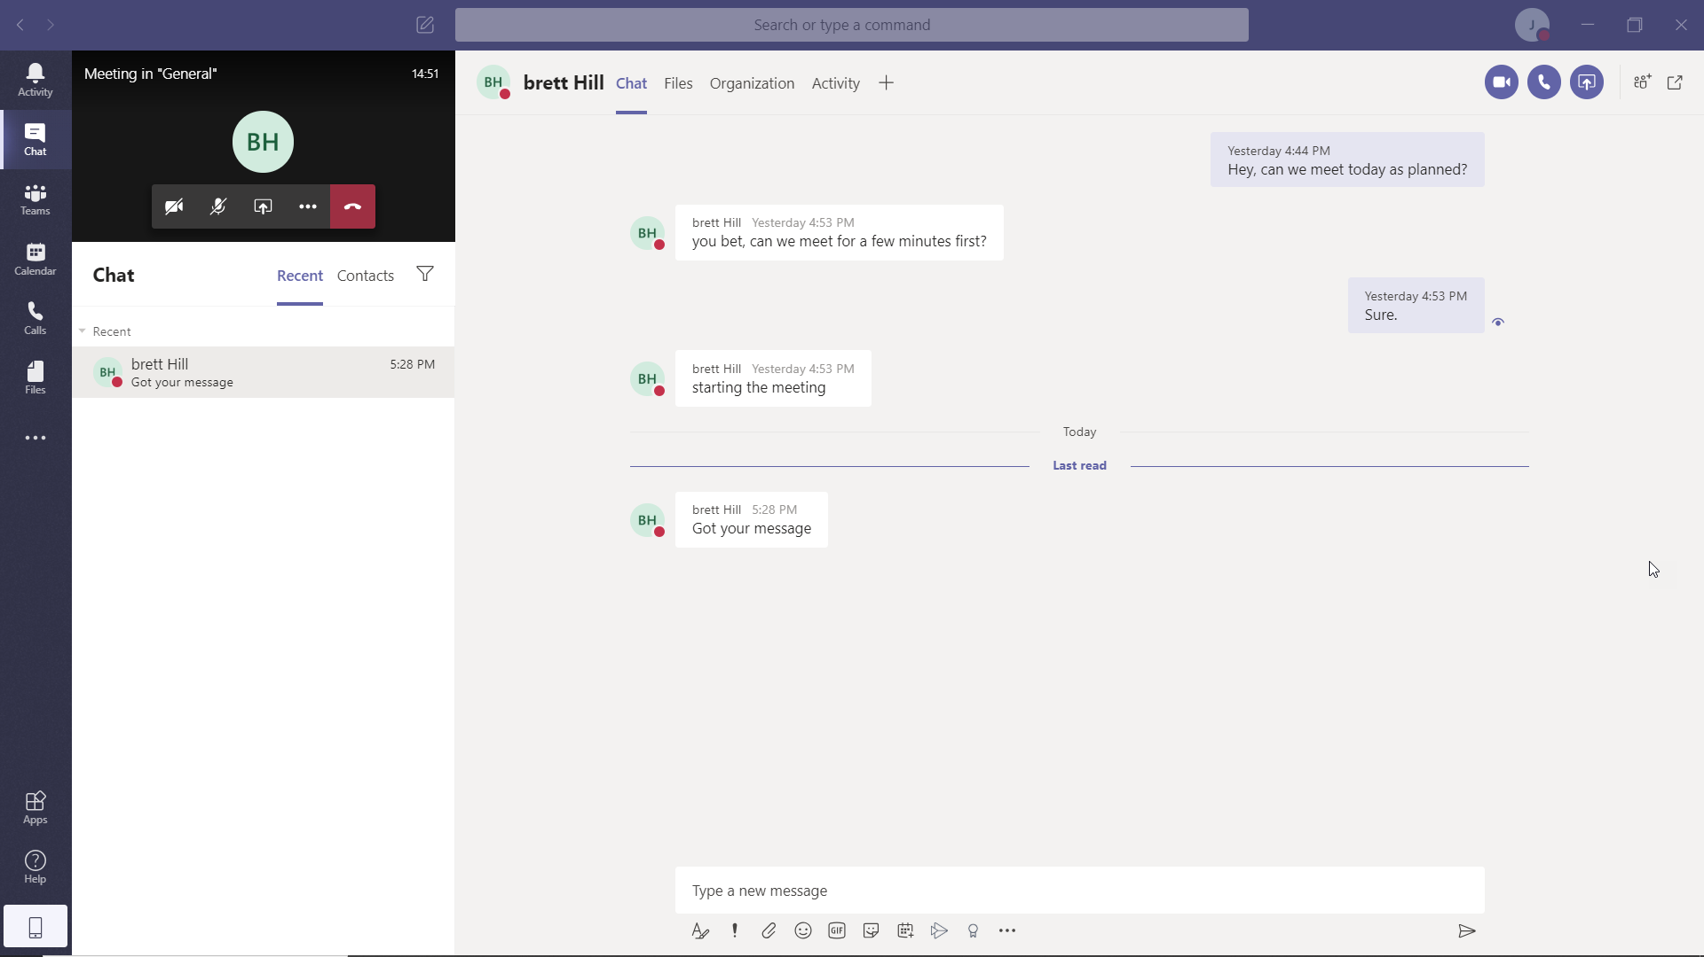

Part 6: Hang Up and End Meeting
The End Meeting option is only available to Team Owners
