Exercise

Contact Groups aka Distribution Lists
Follow along with the video and practice creating a new Contact Group using your existing Outlook People (Contacts) section.
Open your contacts view by clicking the People button:
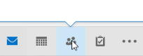 OR 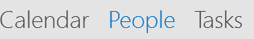
- Click New Contact Group
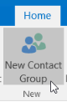
- Name the Group and click “Add Members”:
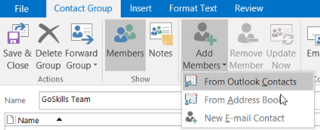
- Select and Double Click the names to be added to the Group:
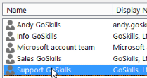
- If you need to Remove someone, open the Group and select “Remove Member”
