Solution

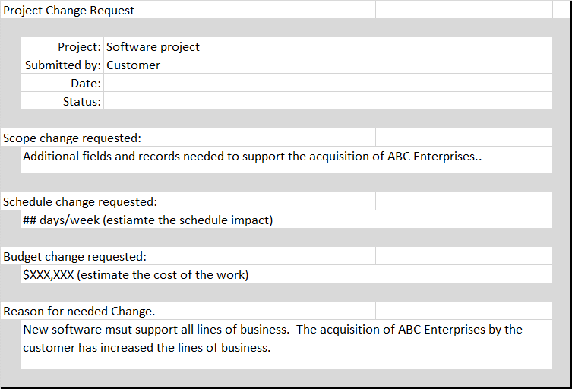
Scope Creep
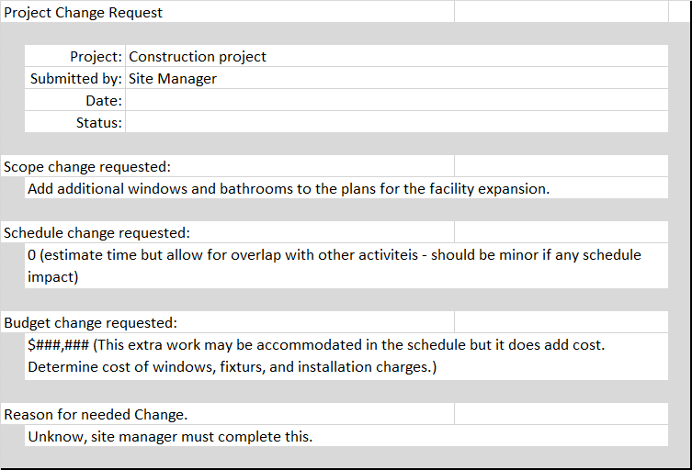
- The customer’s request for more fields and records is scope creep. These were never intended to be in the original project. However, they are now needed. The customer should process a change order to the project to include these. The change in testers is not scope creep. User acceptance testing was already in the plan, all that is changing is which user.
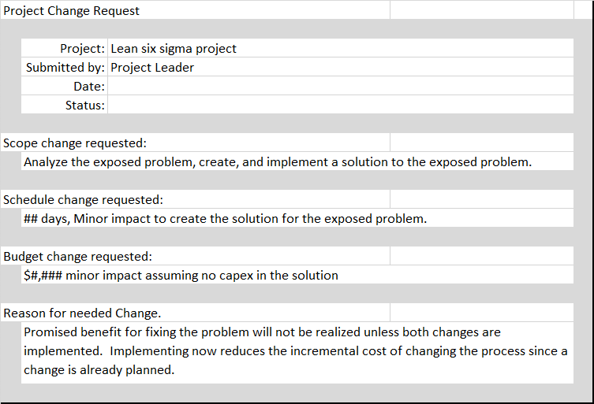
- The direction to add bathrooms and windows is scope creep. The project authorization should be modified to show the additional cost and schedule required for these changes and this should be brought to the funding authorities as soon as possible. They can make the decision whether to approve the changes. Electrical drawings had to be created and approved, having a certified electrician sign off should not add any scope – although it may create a delay depending upon their availability.
- The process change to fix the original problem is in scope, the process change for the unmasked problem scope creep. However, the team should propose to make the change. They have already done the analysis and they will already be modifying the process. Although it is scope creep, the team should advocate for an expansion on their project charter to fix both problems.

