Solution

Explore the OneDrive Interface

​What is OneDrive?
OneDrive is Microsoft's offering when it comes to cloud storage. It is similar to Google Drive in that we can save a file to OneDrive and access that file from wherever we have an internet connection.
There are two types of OneDrive account: OneDrive - Personal and OneDrive - Business. You may have one or both of them on your PC.
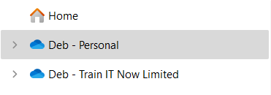​

Access OneDrive
OneDrive will be set up automatically when you install Microsoft 365. Simply walk through the wizard to set it up. However, if we skipped over this step during the setup phase we can do it later on.
- Click the Start menu in the Windows taskbar
- Search for 'OneDrive'
- Click on OneDrive App
- Walk through the setup process
When OneDrive is installed, we can see a cloud icon in the system tray. You will see an icon for each OneDrive account that you have.
​

OneDrive Online vs OneDrive
We can access our OneDrive files online through Microsoft 365 or we can synchronize our files with File Explorer on our computer.
Synchronizing makes it quicker and easier to access our files as it means we don't need to log into the online portal each time we need to open a file. We can choose to synchronize all files or specific folders.

OneDrive Online
- From the App Launcher, click OneDrive
We can access our files by selecting options in the left-hand menu. The files list under Recent can be filtered by file type by clicking on the buttons. We can also access files stored in Teams or shared in M365 groups from here.
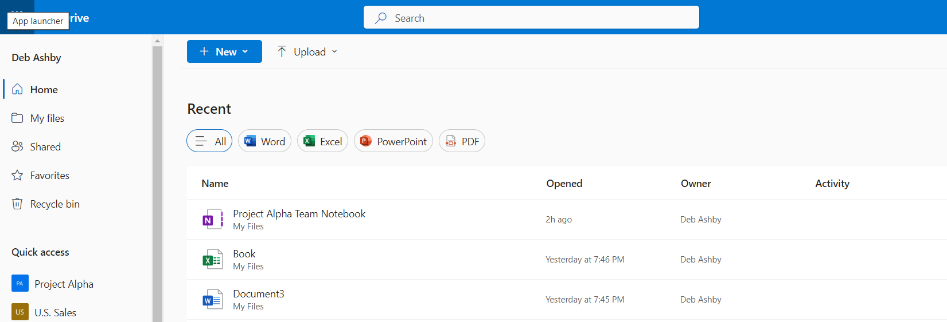​

My Files
- Click on My Files
This area shows a list of all of the files we have created or uploaded. Folders will have a folder icon next to them. We can create new files and folders directly from within OneDrive or we can upload existing files from File Explorer.
Use the breadcrumb trail to navigate.
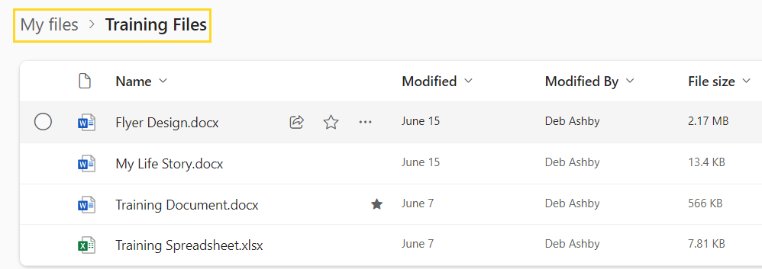​
- Click on any file to open it in the relevant online application
Changes made to any file will automatically synchronize and save. We do not need to click the Save button when working in Word documents and Excel spreadsheets for example.
- Click the three dots next to any file to see more options
From here we can open the file, share the file, download it, rename etc.
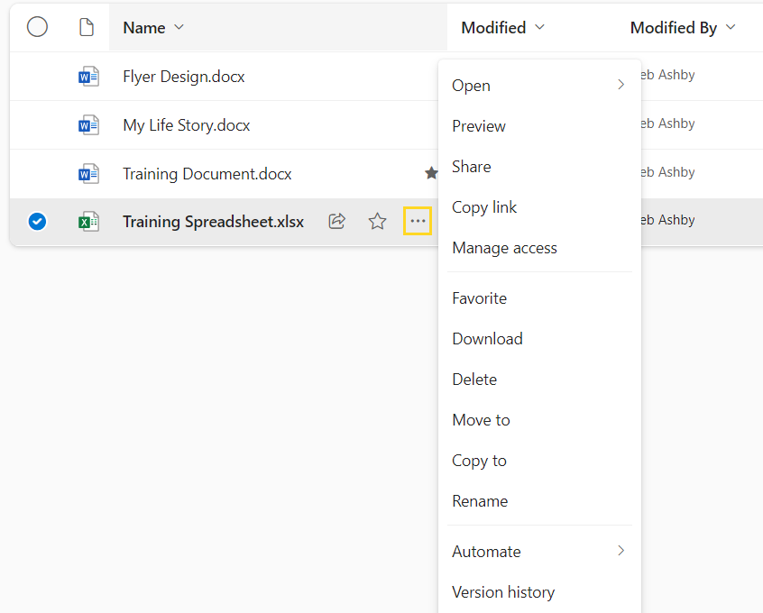​We can sort and filter the list of files using the menus in the top right-hand corner.


