Solution

Co-authoring Files and Documents

Co-authoring in Word Online
- Open Word from the App Launcher
- Open ‘Guide to Office Online.docx’
- Click the Share button in the top right-hand corner
- Click Share again
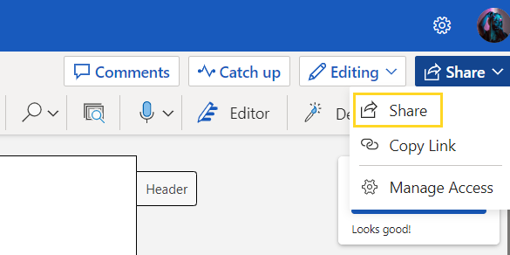
- Type the names of the people to share the document with
- Set the access level to Can edit
- Click Apply
- Click Send
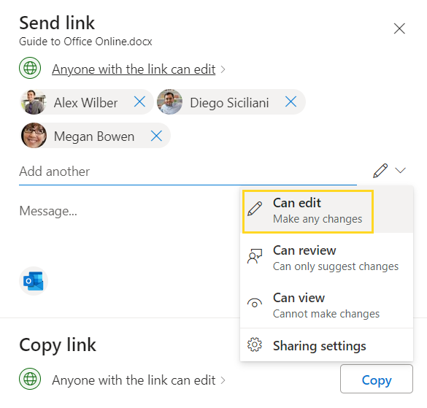
The invitees will receive an Outlook email with a link to the document. When they open the document, we can see their profile photo at the top of the document and we can also see where they are clicked in the document.
