Exercise

Earnings Statement Part 2
An extract of the 2014 annual report from the Cisco corporation is shown below.
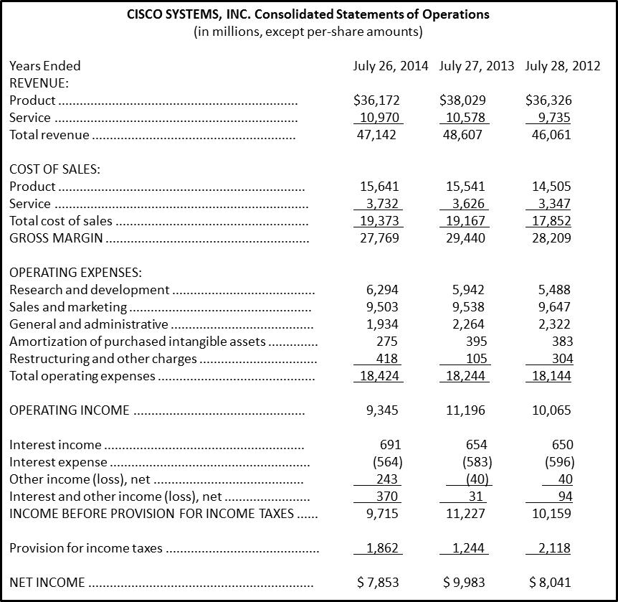
- In which fiscal year did Cisco have the highest Total Revenue?
- In which year did Cisco have the highest Service Revenue?
- In which year did Cisco have the lowest Product Revenue?
- What percentage of Total Revenue is the Product Revenue in each year?
- What is the average rate of growth in the Service Revenue for 2012 to 2014?
- Based upon these Sales values, what are the strengths and weaknesses you see in Cisco’s sales?

