Solution

Introduction to Database Templates

Creating a Contacts List Database
- Click in the search bar.
- Type in the keyword 'contacts' and press Enter.
- Select the first template from the list of results called 'Contacts'.
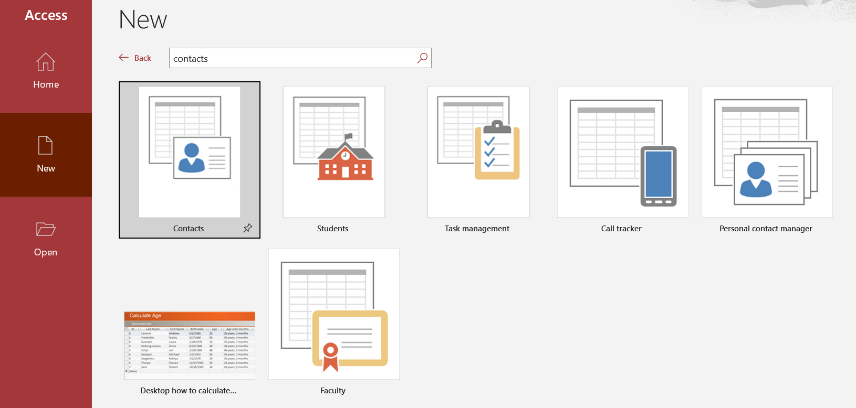
- Templates by default will be assigned a default file name.
- Click the Browse button and choose a folder to store this template in.
- Click Create.
Once the template has been created, it will load into the main window. A navigation pane is displayed on the left-hand side and each element of the template is grouped by category.
A security warning will show in a yellow bar across the top of the main window. This is a check to ensure that the template has been downloaded from a reputable source and doesn't contain any malicious code that may harm your PC. This template has been provided by the Microsoft Corporation so it’s from a trusted source.
- Click Enable Content.

The Welcome Screen
The Welcome screen will pop up whenever we open a template. It provides information about the template, links to help files and a short video about the template and how to use it.
The Welcome screen can be customized for your users and even disabled. We will discuss this more later.
- Close the Welcome screen.
- Click the File tab and select Close to close the contacts database.

Exercise notes
- The keyboard shortcut to close a database is CTRL+W.

