Solution

Creating a Table and Adding Fields

Creating a Table
The first table we are going to create is a table that holds all of the information related to trips for Footprints Travel. We have trip information for the first trip stored in a text file. Let's take a look at it.
- Download the file 'Trip_Example.txt'.
The text file shows information related to the Morocco trip.
- Review the trip information and the fields.
- Some fields, such as ‘Type’, have multiple options.
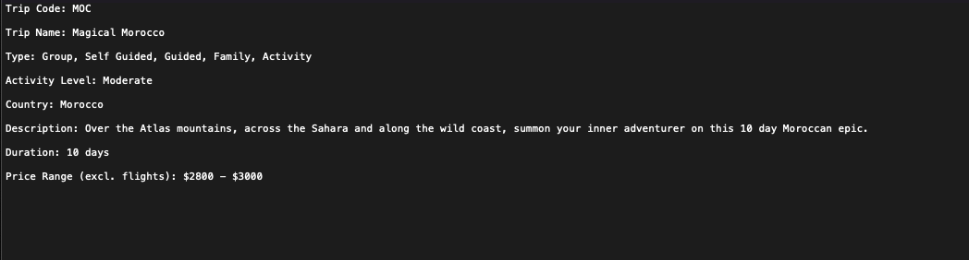
We will use these fields as the column headings in our table.
- From the Create tab, click on Table.
The new table is given a default name of 'Table1'. Let's rename the table.
- Right-click on the table name.
- Select Rename from the list.
If we choose to do anything else at this stage, such as switch to Design view, we will be asked to give the table a name.
- Name the table ‘tblTrip’.
- Click OK.
- From the Home tab, click Views and select Design View.

Working with table fields
- Click Description for the ‘ID’ field and type 'Unique code for this trip’'.
- Click in the box underneath ‘ID’ in the Field Name column.
- Type 'Code’'.
- In the Data Type column, click the drop-down and select Short Text.
- Add the description '3 char code for this trip'.
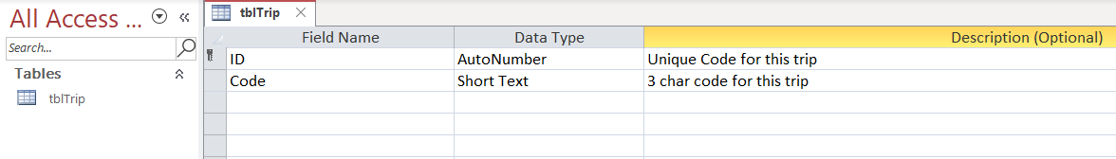

Modifying Field Properties
- Click on the Code field.
- Modify the field properties:
Field Size
- Click in Field Size.
- Change this to ‘3’.
Required
This property defines if this field is required in order to save the record. In our example, every trip must have a trip code.
- Click in Required.
- Click the drop-down arrow or double-click to change the property to Yes.
Allow Zero Length
This property defines if we are going to allow trip codes of zero length.
- Click in Allow Zero Length
- Change this to No.
Indexed
This property defines if the field is going to be indexed. Indexing improves the efficiency of the database when searching through large numbers of records.
- Click in Indexed.
- Change this to Yes (Duplicates OK).

