Solution

What is Planner and Why is it Useful?

What is Microsoft Planner?
Microsoft Planner is an application available as part of your Microsoft 365 subscription. It’s used for organizing individual or team tasks in a collaborative, intuitive environment.
In Microsoft Planner we can keep track of tasks, organize them into buckets, add labels, track progress, create subtasks, assign tasks to others and monitor task progress. We can do all of this in a simple to use dashboard style interface in the cloud. This means, we can download the Planner app and take our tasks with us on the go so we are always on top of outstanding teamwork.
Microsoft Planner is part of Microsoft 365 and so connects easily with applications like ToDo, Teams and SharePoint.
Planner is really the starting point for low-level project management. If you just want a simple application to keep track of teamwork and tasks, Planner is a great option. Plus, if you already gave a M365 subscription, then you already have Planner and can get working immediately.

Launch Microsoft Planner
- Go to office.com
- Log into your Microsoft 365 portal using your email address and password.
- Click the App Launcher in the top left-hand corner.
- Select Planner from the application list.

Tour the Interface

The Hub
The hub is the first page we arrive on when we load up Planner. On the left-hand side we have a menu where we can create a brand-new plan, get back to the hub or see just the tasks that are assigned to us.
- Click Hub to see all existing plans.
Plans in the hub are organized into three groups: Recent, All and Pinned.
The Recent list will show all plans we've recently accessed, All will show all existing plans, and Pinned will show any plans we've chosen to pin to the top of the list. In general, we pin plans that we use frequently.
- Click Assigned to me.
This section shows any tasks that have been assigned to us by ourselves or other people. It's a quick way of accessing and viewing just the tasks that we need to action.

Settings
- Click the cog icon in the top right-hand corner.
This opens up Settings. From here we can check our license, change our notification settings, send feedback to Microsoft, change the theme, change our language and time zone, change our password and update our contact preferences.

Help
- Click the question mark icon in the top right-hand corner.
This gives us access to the help files if we are looking for guidance on how to execute a specific task.

Account Settings
- Click on your profile photo in the top right-hand corner.
From here we can access our account details and settings.

The Plan Interface

Open an Existing Plan
- Click on an existing plan to load it into the main window.

Plan Views
Board view is the default view and the view we work in most frequently. It shows the cards for each task organized into buckets (if we've set them up). We can see the basic details of the task displayed on the card and can click on the card to make changes and see the full details.
Charts view gives us a visual overview of our plan. It shows different charts that summarize some key indicators in the plan such as the number of tasks that are in progress and completed, the number of tasks assigned to buckets etc.
Schedule view shows our tasks displayed on a calendar based on the tasks start and end dates. It gives us a high-level overview and allows us to easily see tasks that overlap, task durations and when projects are going to finish. Tasks can be color coded to group them visually in the calendar.
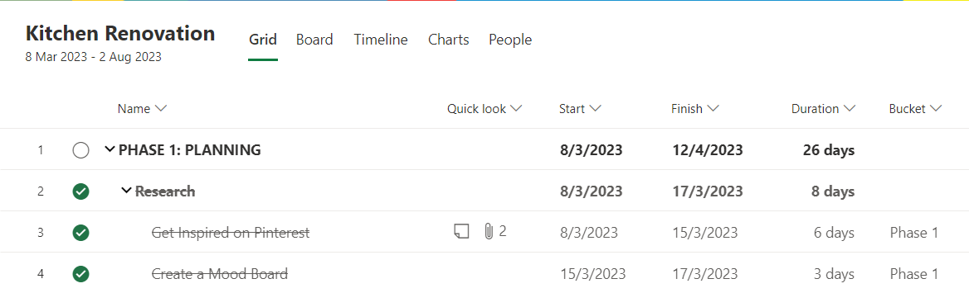

Members
We can see who is a member of this plan by clicking the members button in the top right-hand corner. We can add members from here by typing someone's name or email address into the search bar at the top.
Members have access to the plan and can view/edit tasks.

Filters
The Filters button lets us filter our tasks based on whatever criteria we select from the list. This can be helpful particularly for large plans with many tasks as we can cut through the noise and see only what's of importance to us.
We can filter tasks by due date, priority, progress, label, bucket, assignment and much more.

Group By
The Group By button lets us choose how to group tasks in our plan. We can group by bucket, assigned to, progress, due date, labels and priority.
What we choose to group by affects the buckets displayed in Board view.

Privacy Settings
When we create a plan, it can be set to public or private. Private plans are only viewable by plan members we invite.
- Click the i icon on the plan photo to check the privacy.

Exercise notes
- Use three dots in Planner to access More options.

