Solution

Create a Plan

Download the Exercise File
- Download the file ‘Employee Onboarding.xlsx’ from the exercise files folder.

Create a New Plan
- From the Hub, click New plan.
- Type a name for the plan, i.e. Kitchen Renovation.
- Choose Private.
- Expand Options.
- Add a Group description (optional).
- Click Create plan.
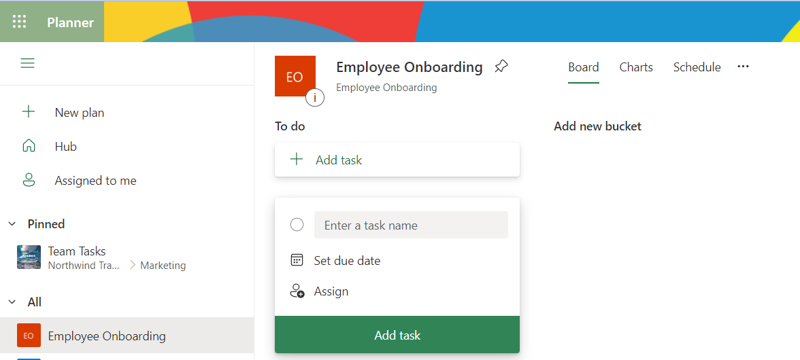
- Go to Outlook.
- Scroll down the folder list and expand Groups.
- Check the Microsoft 365 group for the plan is listed.
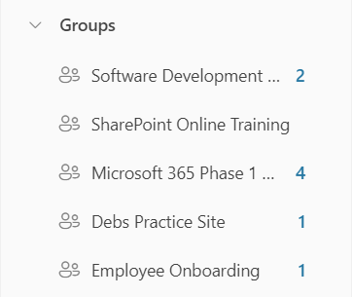

Exercise notes
- It can take a few minutes for Outlook groups to refresh so if the group isn’t there immediately, wait a few seconds and then refresh your browser.

