Exercise

Textbox - Formatting Tools
Go to File, New and find the Newsletter (Soft Blue design).
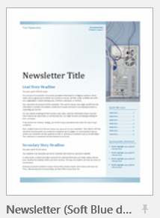
Please explore along with the video to become familiar with the parts of the “Text Box Tools, Format” ribbon.
