Solution

Course Introduction

Download Microsoft Teams
We can use the browser or the desktop version of Teams.

Download Desktop Version
If you already have a Microsoft 365 account, you should have access to Teams through the M365 portal.
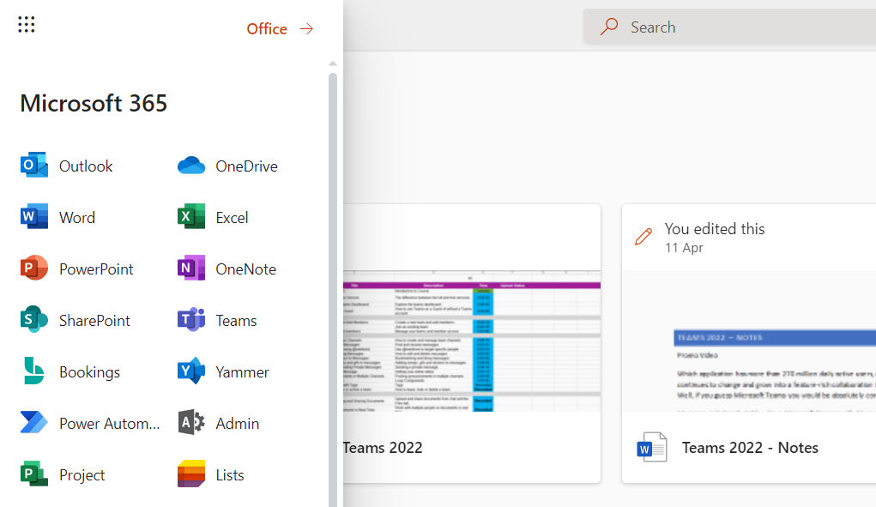
- Open the browser version of Teams.
- Click the three dots in the top right–hand corner.
- Click Download the desktop app.
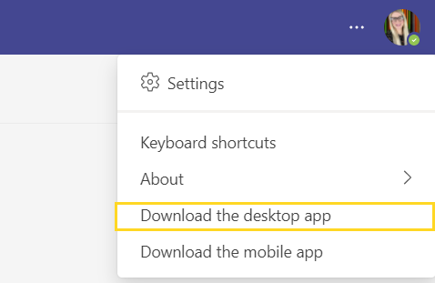

Review the Agenda
Ensure that you have watched the video in the lesson and reviewed the course agenda.

