Solution

Get to Know the PowerPoint Interface

Open a File
- Download the exercise file ’03-02-The PowerPoint Interface’.
- Click the File tab and select Open.
- Browse to the Downloads folder.
- Double-click to open the file.

Explore the Ribbon.
- Click through each of the tabs in the ribbon to become familiar with the layout, structure, and location of commands.
- Click on the placeholders, images and text and note how the commands and tabs change depending on the selection.

Minimize the Slides Pane
- Hover the mouse of the boundary line.
- When the cursor changes to a double-headed arrow, drag to the left.

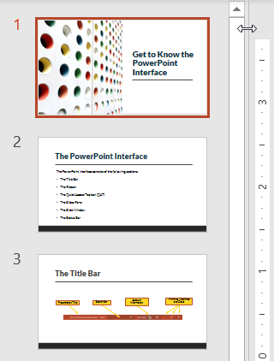

Customize the Status Bar
- Right-click on a blank part of the status bar.
- Select Theme from the Customize Status Bar menu.

