Solution

Story Cards

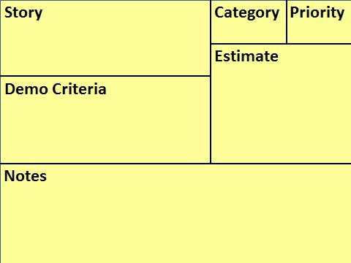
Test all the buttons in the App on iPhone and android and compare results to same action on the website.
Should
Provide an iPhone and android App that has the same functionality as the website.

Document in accordance with SQS223-14 including block diagrams.
Should
Fully document the software.

- Unique user name.
- Pwrd - 8-20 char, letters & num
- Lockout after 5 consecutive tries
Must
Provide a secure login capability.

- This is actually two stories that are in two different categories.

ppt – 10 slides customizable by sales Brochure conforms with Mkt Policy 12. – print 2,000 copies
Should
Create marketing collateral material – ppt deck and tri-fold brochure

Full-scale mockup
Countertop setup
Build 12 units
Want
Create mockup for use by marketing

Determine accuracy to 4 sigma
Determine with 99% confidence level
Must
Test sensor to determine accuracy

