Exercise

Mail Merge to Labels
Follow along with the video to preview the process and establish the mailing list.

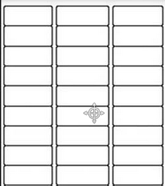

A Anderson
ABC Co.
123 Street
City, State 00000

B Bennett
BCA Co.
231 Street
City, State 00000

C Campbell
CBA Co.
321 Street
City, State 00000

