Exercise

Headers and Footers
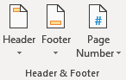

Follow along with the video and use this Exercise document to practice with Headers and Footers.

- Move mouse to top inch of the page, and double click. Observe the three changes to your screen:
  - The document portion is shaded and the header portion is bright
  - The dashed line appears with the header label
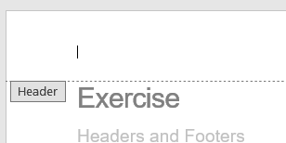
  - A new ribbon opens at the top:
- Scroll to the bottom of the page and change the footer text
- Close the Header/Footer
  - With a double click into the document page
  - Or with the “Close Header/Footer” button on the ribbon

- Open the Header by using the Insert Ribbon, Header button
- Close the Header/Footer

