Exercise

Planning an Event in Trello
Thanks to Trello’s flexible layout and abilities, there are a lot of functions to help prepare an event. From a wedding to a professional event, Trello’s features help you to organize events with attachments, calendar access, to-dos and much more all inside of the board.
Begin your first event
Pick an event that you’ll be organizing in the next 6 months. This could be a birthday party or even a commercial event. Whether this is professional or personal, Trello can scale to each of these regardless of their complexities.
Step 1: Visualize all your to-dos
- Bring together all your tasks for the event by clipping them into lists. For example, you could populate your lists with things like reception area, food, guest list, things to do on the day etc.

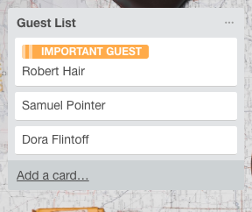

- Plotting these tasks will help you in the first step to seeing all of the things you need to accomplish. Use the labels function to associate importance or even color code certain elements and tasks.

Step 2: Assign due dates and cards
- Begin to add due dates to time-associated tasks. This will help to start mapping the events ahead and what needs to be completed for these dates.
- Activate the “calendar” Power-Up from the Trello menu. Hitting the calendar Power-Up will give you a monthly or weekly view of all of the upcoming tasks and activities.

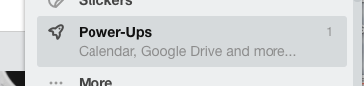
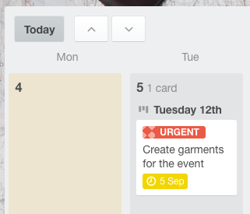

Step 3: Using checklists inside of cards.
- Create basic checklists within Trello to reduce the need for tasks.

Method: Calendar planning
- Try using lists that correlate to dates or weeks to help to plot all of the to-dos ahead.
- This method skips the use of the calendar and provides a running view of what’s happening. The process used here is flexible thanks to Trello’s Kanban layout.

